Salem Main Streets/Salem Farmers’ Market
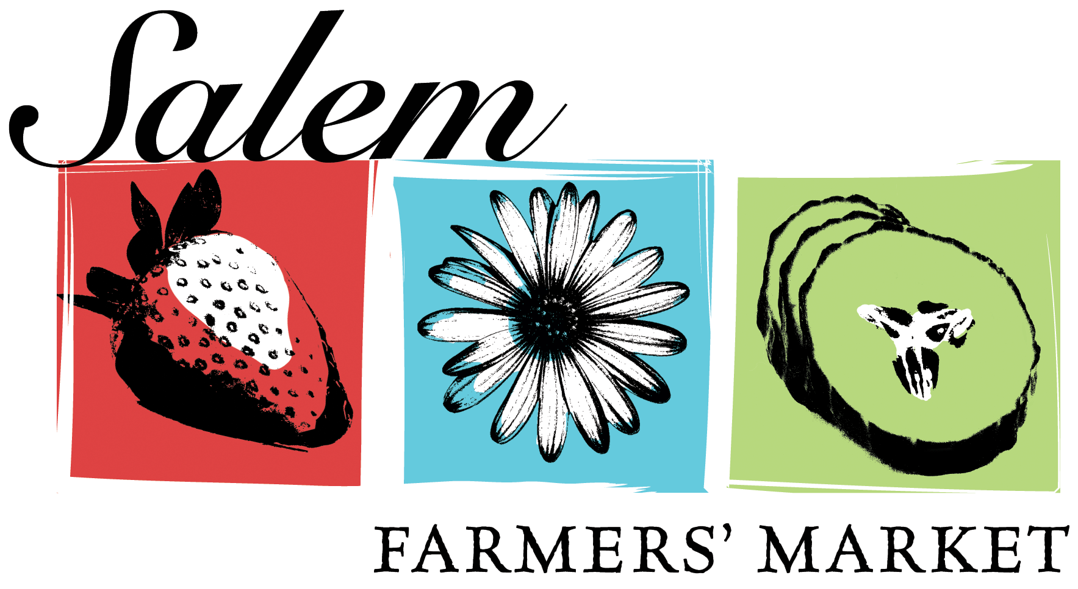
2024 Application Form

Thank you for your interest in the Salem Farmers’ Market. The Market will be held Thursdays from 3 – 7 p.m. in Salem, MA
on Derby Square next to Old Town Hall from June 13 – Oct. 10. Application deadline is March 8, 2024.
O 10’x10’ vendor space $40 weekly O 10’x20’ vendor space $80 weekly O 10’x30’ space $120 weekly
(There is a 10% discount for vendors who prepay for the full season)

O Every week O Every other week – circle preferred start date of June 13 or June 20

Business Name:______________________________________Contact Name: ____________________________________

Address:_____________________________________________________________________________________

Phone #:__________________ Email address:______________________________________

I would like to sell the following products (check all that apply):

O Produce (fresh uncut fruits and vegetables) O Maple Syrup

O Unprocessed Honey O Fresh Eggs (must be stored and maintained at 45ºF/7.2ºC)
O Other – LIST ALL (Complete Board of Health permit application paperwork must be included for these items)
_______________________________________________________________________________________________________________________________________________________________________________________________________________________________________
_____________________________________________________________________________
If a product is not included in this list, you will not be allowed to sell it at the market without first receiving approval from the market manager. For non-farm products only, vendor must add at least 75% of the total value to the products.

Would you require a power source during the market? If so, please explain______________________________

Salem Famers’ Market General Conditions
- I understand and agree to all of the Program Guidelines, Vendor Policies and Board of Health Requirements and Conditions. I understand that the board of health may require additional information in order to process this application.
- If selected, I understand that I must obtain all necessary permits and licenses from the City of Salem.
- I agree to attend each week during the day/time referenced in the program guidelines throughout the entire 2024 Salem Farmers’ Market Season.
- I agree to indemnify and hold harmless Salem Main Streets, the City of Salem and its agents, its servants, volunteers and employees from any and all liability, claim or cause of action for any property damage, personal injury, wrongful death or damage to property or persons arising out of or in connection with any error, omission or negligence by me or my employee or agent while participating in Salem Farmers’ Market.
- I agree to maintain sufficient insurance coverage for property damage and personal injury liability while participating in the Salem Farmers’ Market.
- I agree to maintain the property, including, but not limited to, sweeping up debris and taking all trash with me after each vending day.
- I authorize Salem Main Streets to promote the Salem Farmers’ Market and my participation in the market, including but not limited to, using photographs and descriptions in materials, links to websites, and press releases.
- I understand that Salem Main Streets reserves the right to make changes to any of the vendor policies as warranted.

I ___________________________the owner of Farm/Business _______________________have read the Program Guidelines, Vendor Policies, Board of Health Requirements and Conditions, and the above General Conditions and agree to abide by them and the spirit of this Farmers Market.

Pursuant to MGL C62c, S49A, I certify under the penalties of perjury that I, to the best of my knowledge and belief, have filed all State tax returns and paid all State taxes required under law.

Signature of Owner ____________________________________ Date_______________

Mail Application to: Salem Farmers’ Market, 265 Essex Street #101, Salem, Massachusetts 01970

Questions: Call Salem Main Streets (978) 744-0004 x115 or email kylie@salemmainstreets.org

